🛡️ Automated COVID-19 Crisis Intelligence Pipeline

1. Executive Summary
The Business Problem:
Government health agencies often struggle with "Data Overload"—receiving raw spreadsheets or numbers without actionable context. Critical trends are often missed until it is too late.
The Solution:
An automated pipeline that:
- Ingests daily COVID-19 data from a Postgres data warehouse.
- Analyzes trends using SQL Window Functions to detect specific risk patterns (e.g., "Vaccine Stall").
- Synthesizes a strategic intelligence briefing using Google Gemini (GenAI).
- Delivers a formatted HTML report to stakeholders via Email.
Tech Stack:
- Orchestration: n8n (Workflow Automation)
- Database: PostgreSQL (Data Warehousing)
- Intelligence: Google Gemini 3 (27b)
- Delivery: SMTP / HTML Email

2. Architecture Overview
The pipeline moves from Raw Data -> Actionable Intelligence in four distinct stages:
- Risk Detection (SQL Layer): Filters 100+ rows down to critical "At Risk" states using math for a particular date.
- Aggregation (Code Layer): Transforms individual row data into a consolidated dataset for the AI.
- Reasoning (AI Layer): A Large Language Model (LLM) interpreting the numbers and generating strategic advice.
- Distribution (Notification Layer): Sends a clean, professional HTML report to decision-makers.

3. Workflow Configuration (Step-by-Step)
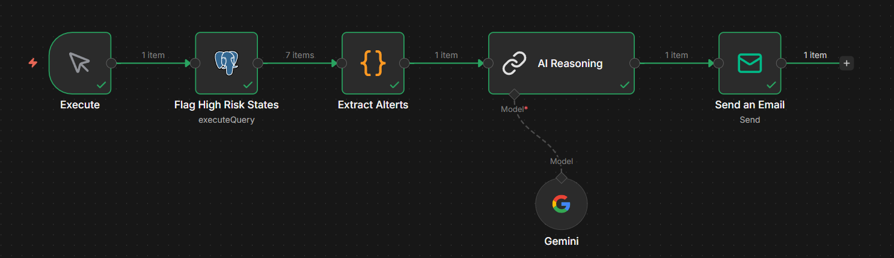

🟢 Node 1: Postgres (The Filter)
- Purpose: Extract only the states that require attention for the input date. We do the heavy calculation inside the database.
- Key Logic:
  - Calculates daily_vax_growth_pct using LAG() window functions.
  - Applies a composite filter: (Low Vax Growth) AND (Rising Cases) AND (Cases > 500).
SQL Query:
WITH history AS (
SELECT
state,
date,
daily_new_cases,
positive_test_rate,
population,
vaccination_rate,

LAG(daily_new_cases, 1) OVER (PARTITION BY state ORDER BY date) as cases_1_day_ago,
LAG(daily_new_cases, 2) OVER (PARTITION BY state ORDER BY date) as cases_2_days_ago,
LAG(daily_new_cases, 3) OVER (PARTITION BY state ORDER BY date) as cases_3_days_ago,

vaccination_rate - LAG(vaccination_rate, 1) OVER (PARTITION BY state ORDER BY date) AS daily_vax_growth_pct

FROM covid_summary_clean
WHERE date >= '2021-07-01'
),
risk_analysis AS (
SELECT
*,
-- RISK A: 3 Consecutive Days of Rising Cases
CASE
WHEN daily_new_cases > cases_1_day_ago
AND cases_1_day_ago > cases_2_days_ago
AND cases_2_days_ago > cases_3_days_ago
THEN TRUE ELSE FALSE
END as risk_consecutive_rise,

-- RISK B: High Positivity Rate (> 10%)
CASE
WHEN positive_test_rate > 10 THEN TRUE ELSE FALSE
END as risk_high_positivity,

-- RISK C: Vaccination Stalled & High Volume Cases (> 500)
CASE
WHEN daily_vax_growth_pct < 0.1
AND daily_new_cases > cases_1_day_ago
AND daily_new_cases > 500
THEN TRUE ELSE FALSE
END as risk_vax_stall
FROM history
)
SELECT
state,
date,
daily_new_cases,
positive_test_rate,
population,
vaccination_rate,
CONCAT_WS(' | ',
CASE WHEN risk_consecutive_rise THEN '⚠️ Outbreak Trend: Cases rising for 3 consecutive days' END,
CASE WHEN risk_high_positivity THEN '⚠️ High Positivity: Rate > 10%' END,
CASE WHEN risk_vax_stall THEN '⚠️ Vulnerability: Vaccination stalled while cases are rising' END
) as risk_summary
FROM risk_analysis
WHERE
date = '2021-08-11'
AND (risk_consecutive_rise OR risk_high_positivity OR risk_vax_stall);

🟠 Node 2: Code Node (The Aggregator)
- Purpose: Batch processing. Instead of sending 5 separate emails (which spams the user and hits API limits), we combine all risky states into one context object.
- Language: JavaScript.
Key Code:
const items = $input.all();
if (items.length === 0) {
return [{ json: { full_report: " No critical risks detected today." } }];
}
let reportText = "";
items.forEach((item, index) => {
const s = item.json;
const casesPerMillion = Math.round((s.daily_new_cases / s.population) * 1000000);
reportText += `### ${index + 1}. ${s.state} (Pop: ${(s.population / 1000000).toFixed(1)}M)\n`;
reportText += ` - 🦠 New Cases: ${s.daily_new_cases} (${casesPerMillion} per million)\n`;
reportText += ` - 🧪 Positivity: ${s.positive_test_rate}%\n`;
reportText += ` - 💉 Vax Rate: ${s.vaccination_rate}%\n`;
reportText += ` - ⚠️ Flag: ${s.risk_summary}\n\n`;
});
return [{
json: {
report_date: items[0].json.date,
total_states: items.length,
full_report: reportText
}
}];

🔵 Node 3: AI Reasoning
- Purpose: Turns raw numbers into human-readable strategy.
- Model: gemma-3-27b .
- Prompt Strategy: "Role Prompting" (Acting as Chief Data Officer) + "Chain of Thought" (Analyze -> Conclude).
- Key Instruction: "Generate the report in HTML format directly to ensure perfect rendering."

🟣 Node 4: Email
- Purpose: Sends the final report.
- Configuration:
  - Subject: ⚠️ CRITICAL COVID-19 ALERT
  - Format: HTML.
  - Cleanup: Uses {{ $json.text.replace(/```html/g, '').replace(/```/g, '') }} to remove Markdown wrappers that might break the email.

